**DevOps:**

<https://talmedia.net>

<https://github.com/nzthiago>

Introduction to DevOps

DevOps is defined by different people in different ways:

“DevOps is development and operations collaboration”

But not only dev and ops get involve but other teams like QA, security, business etc. also get involved.

“DevOps is treating your infrastructure as code”

“DevOps is using automation”

“DevOps is feature switches”

DevOps: The three-stage conversation:

* People
* Process
* Products

Benefits of DevOps:

* Strong IT performance is a competitive advantage
* DevOps practices improves IT performance
* Deploy code 30x faster
* Have 60x fewer failures

DevOps Frame:

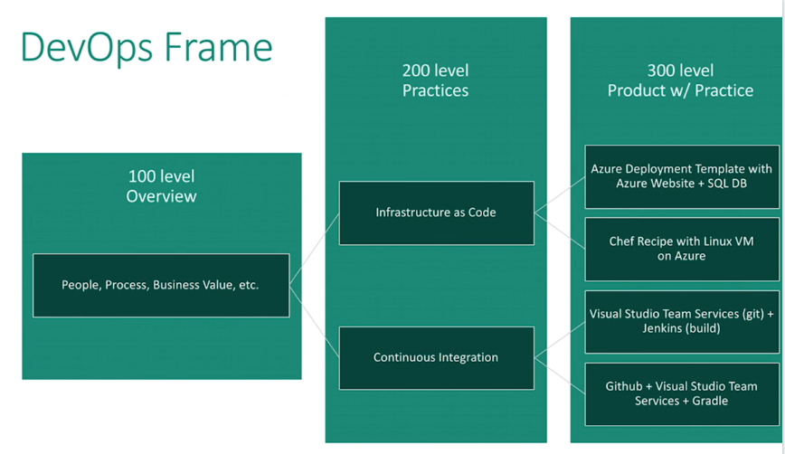

List of DevOps Practices:

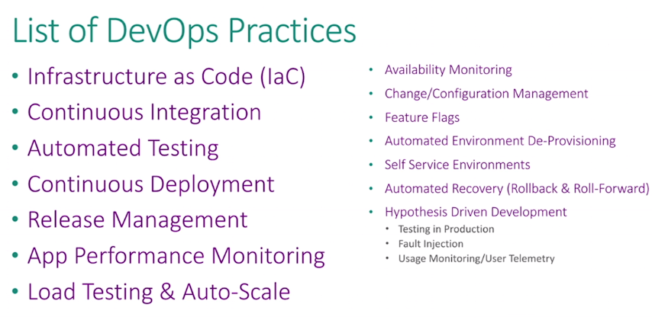

Microsoft Azure is one of the best tools for DevOps.

7 Habits for DevOps Success (in Microsoft):

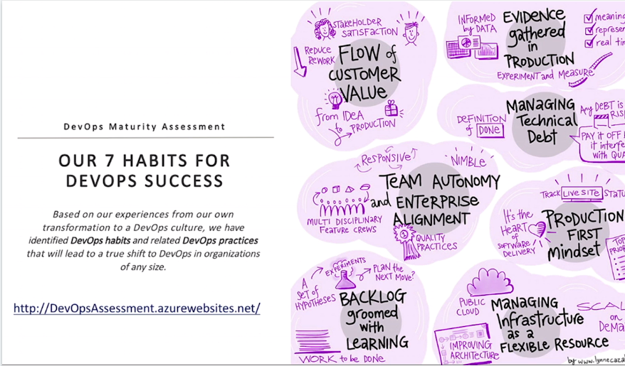

DevOps Fundamentals: Structure as Code